**Guvi Task 11**

**Spring IOC, Beans, IOC**

**Q2.You are tasked with developing a web application that allows users to submit their feedback through a web form. The feedback data should be stored in a MySQL database, and upon successful storage, the application should respond with "feedback saved".**

**The first restful URL should display the html page where the user can enter name, book name and feedback, and user can click one submit button.**

**Form page**

**<!DOCTYPE html>**

**<html xmlns:th="http://www.thymeleaf.org">**

**<head>**

**<title>Feedback Form</title>**

**<link href="https://cdn.jsdelivr.net/npm/bootstrap@5.3.6/dist/css/bootstrap.min.css" rel="stylesheet"**

**integrity="sha384-4Q6Gf2aSP4eDXB8Miphtr37CMZZQ5oXLH2yaXMJ2w8e2ZtHTl7GptT4jmndRuHDT" crossorigin="anonymous">**

**<script src="https://cdn.jsdelivr.net/npm/bootstrap@5.3.6/dist/js/bootstrap.bundle.min.js"**

**integrity="sha384-j1CDi7MgGQ12Z7Qab0qlWQ/Qqz24Gc6BM0thvEMVjHnfYGF0rmFCozFSxQBxwHKO"**

**crossorigin="anonymous"></script>**

**</head>**

**<body>**

**<div class="container mt-4 d-flex justify-content-center">**

**<h2>Submit Feedback</h2>**

**</div>**

**<div class="container d-flex justify-content-center">**

**<form th:action="@{/submit}" th:object="${feedback}" method="post">**

**<label>Your Name:</label><br>**

**<input type="text" th:field="*{name}" required/><br><br>**

**<label>Book Name:</label><br>**

**<input type="text" th:field="*{bookName}" required/><br><br>**

**<label>Feedback:</label><br>**

**<textarea th:field="*{feedback}" required></textarea><br><br>**

**<button class="btn btn-primary" type="submit">Submit</button>**

**</form>**

**</div>**

**</body>**

**</html>**

**Result html page:**

**<!DOCTYPE html>**

**<html xmlns:th="http://www.thymeleaf.org">**

**<head>**

**<title>Result</title>**

**<link href="https://cdn.jsdelivr.net/npm/bootstrap@5.3.6/dist/css/bootstrap.min.css" rel="stylesheet"**

**integrity="sha384-4Q6Gf2aSP4eDXB8Miphtr37CMZZQ5oXLH2yaXMJ2w8e2ZtHTl7GptT4jmndRuHDT" crossorigin="anonymous">**

**<script src="https://cdn.jsdelivr.net/npm/bootstrap@5.3.6/dist/js/bootstrap.bundle.min.js"**

**integrity="sha384-j1CDi7MgGQ12Z7Qab0qlWQ/Qqz24Gc6BM0thvEMVjHnfYGF0rmFCozFSxQBxwHKO"**

**crossorigin="anonymous"></script>**

**</head>**

**<body>**

**<div class="container mt-4 d-flex justify-content-center">**

**<h2>Result</h2>**

**</div>**

**<hr>**

**<div class="container d-flex justify-content-center">**

**<h2 th:text="${message}"></h2>**

**</div>**

**<br>**

**<div class="container d-flex justify-content-center">**

**<a class="btn btn-secondary" href="/">add feedback</a>**

**</div>**

**</body>**

**</html>**

**Entity:**

**package com.example.feedbackform.Entity;**

**import lombok.Data;**

**@Data**

**public class feedback {**

**private String name;**

**private String bookName;**

**private String feedback;**

**}**

**Controller:**

**package com.example.feedbackform.Controller;**

**import com.example.feedbackform.DAO.feedbackDAO;**

**import com.example.feedbackform.Entity.feedback;**

**import org.springframework.beans.factory.annotation.Autowired;**

**import org.springframework.stereotype.Controller;**

**import org.springframework.ui.Model;**

**import org.springframework.web.bind.annotation.*;**

**@Controller**

**public class feedbackController {**

**@Autowired**

**private feedbackDAO feedbackDAO;**

**@GetMapping("/")**

**public String showForm(Model model) {**

**model.addAttribute("feedback", new feedback());**

**return "form";**

**}**

**@PostMapping("/submit")**

**public String submitFeedback(@ModelAttribute feedback feedback, Model model) {**

**try {**

**feedbackDAO.saveFeedback(feedback);**

**model.addAttribute("message", "feedback saved");**

**} catch (Exception e) {**

**model.addAttribute("message", "error saving feedback");**

**}**

**return "result";**

**}**

**}**

**DAO:**

**package com.example.feedbackform.DAO;**

**import com.example.feedbackform.Entity.feedback;**

**import org.springframework.beans.factory.annotation.Autowired;**

**import org.springframework.stereotype.Repository;**

**import javax.sql.DataSource;**

**import java.sql.Connection;**

**import java.sql.PreparedStatement;**

**@Repository**

**public class feedbackDAO {**

**@Autowired**

**private DataSource dataSource;**

**public void saveFeedback(feedback feedback) throws Exception {**

**String sql = "INSERT INTO feedback (name, book_name, feedback) VALUES (?, ?, ?)";**

**try (Connection conn = dataSource.getConnection();**

**PreparedStatement ps = conn.prepareStatement(sql)) {**

**ps.setString(1, feedback.getName());**

**ps.setString(2, feedback.getBookName());**

**ps.setString(3, feedback.getFeedback());**

**ps.executeUpdate();**

**}**

**}**

**}**

**OUTPUT:**

**Add Feedback:**

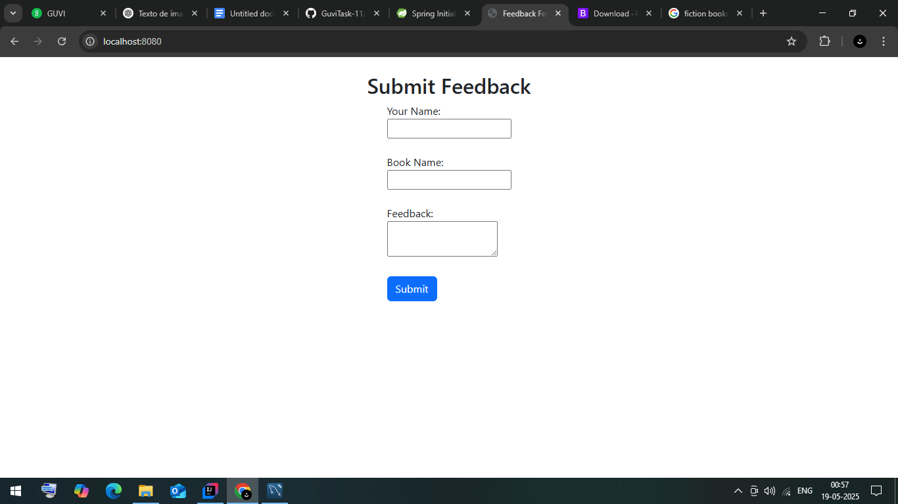

**Result page:**

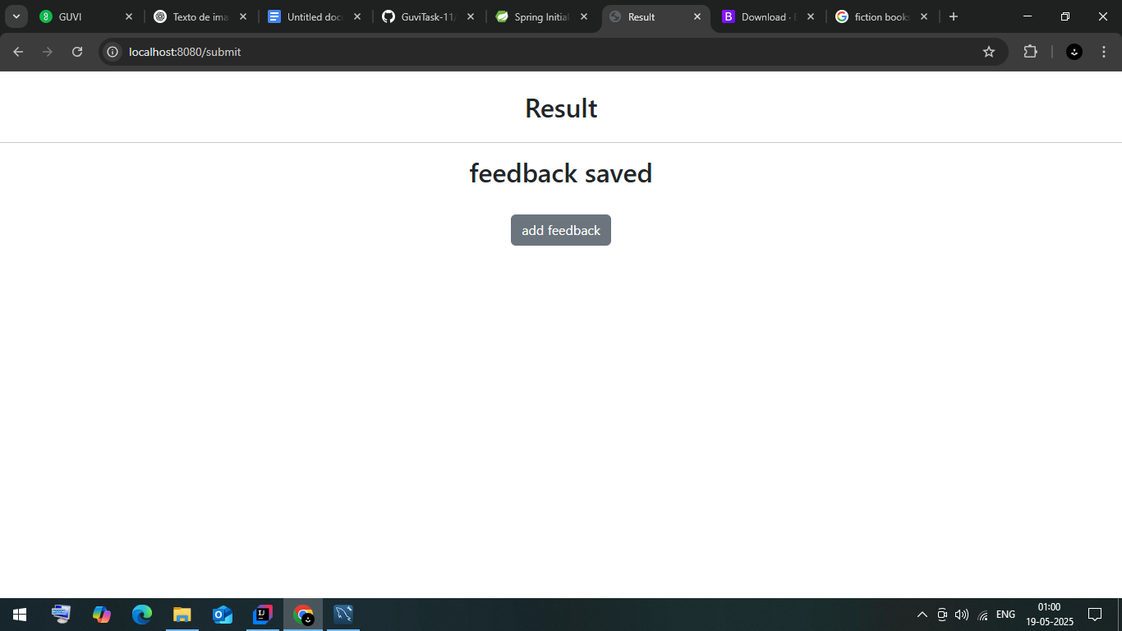

**Database:**

